**SECURE CODING**

**LAB ASSIGNMENT – 3**

**EXECUTION OF COMMANDS**

NAME : SREENIDHI GANACHARI

REGISTRATION NUMBER : 19BCE7230

SLOT : L – 39 – 40

1) Use of pushd and popd to change the directory .

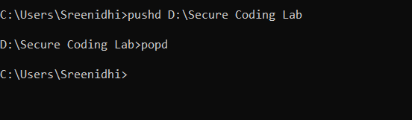

Absolute path – Here the path “**C:\Users\Sreenidhi>** “ is the absolute path i.e shows the directory from the root .

Relative path – Here the relative path “**Users\Sreenidhi>** “ or “**Sreenidhi>”** come under relative path where the directory is not from the root.



ATTRIBUTES –

1)Used the +h and -h to hide and clear the folder “**Secure Coding**”.

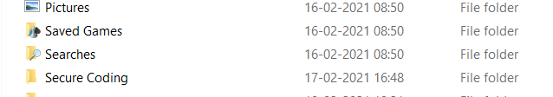



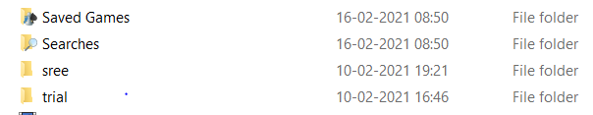



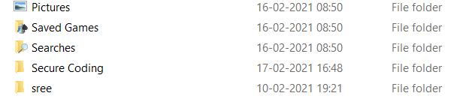

2) Using the +r and -r commands for read only mode of the file .

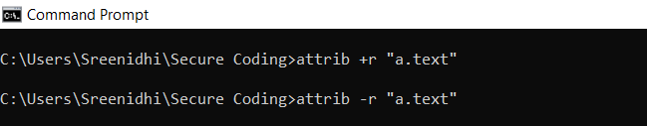

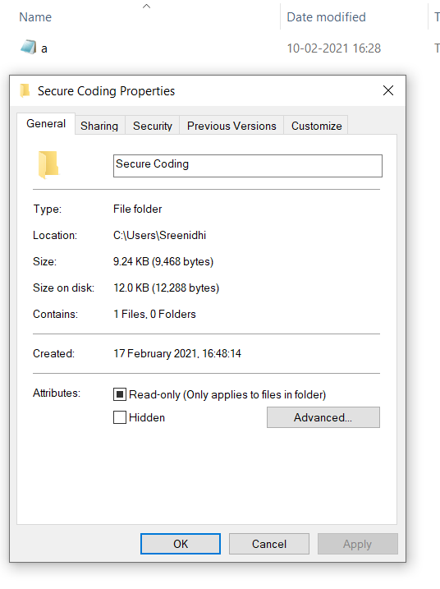

Attributes – Implementing all the attribute commands for the a.text file .

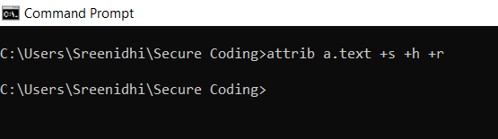

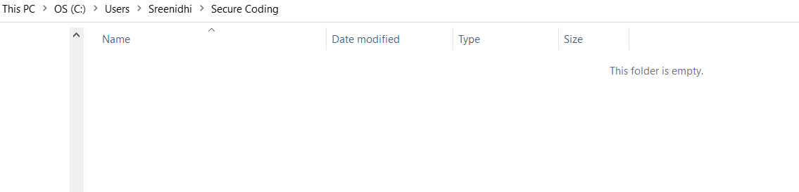

**WHERE command** – It displays the location of files that match the search pattern .

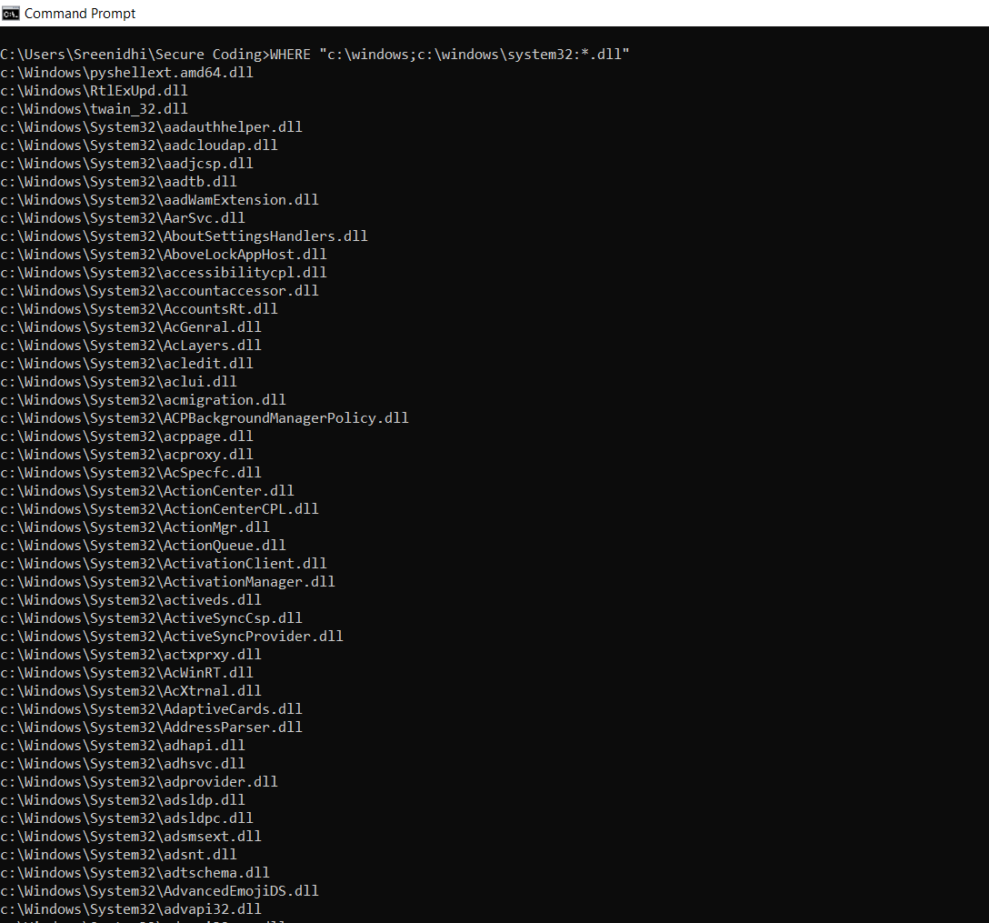

Implementing various task functions –

1) tasklist/apps

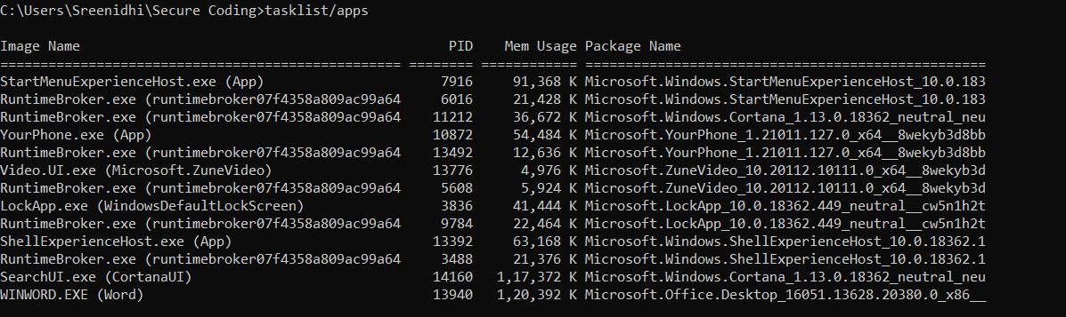

2)tasklist

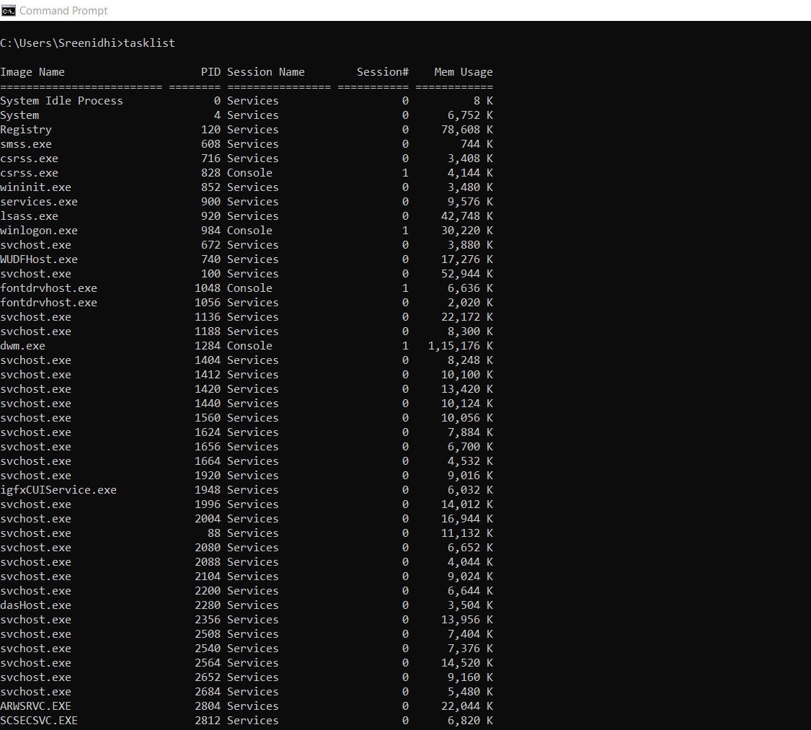

3)tasklist/svc

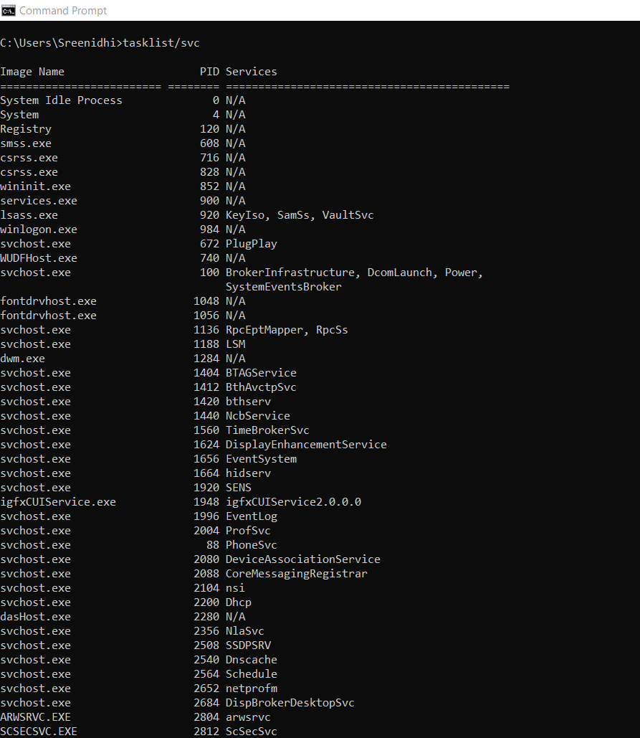

4)tasklist/m

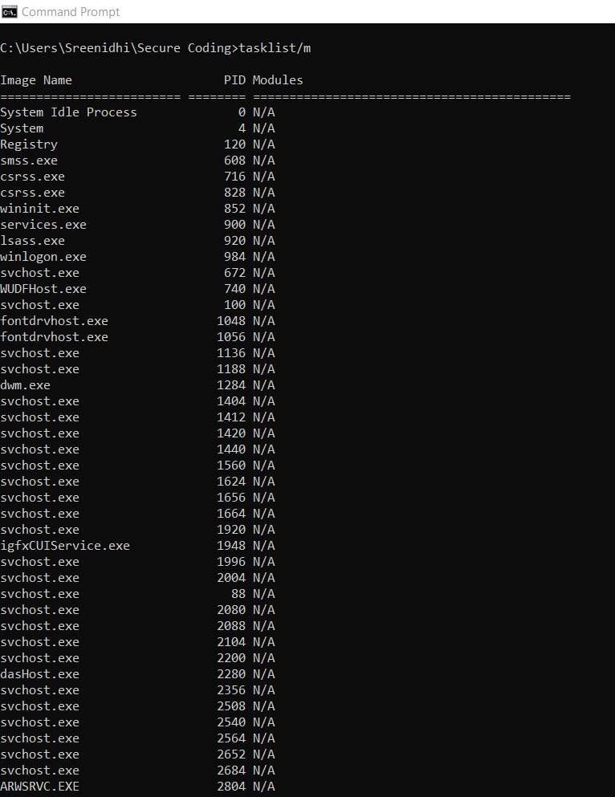

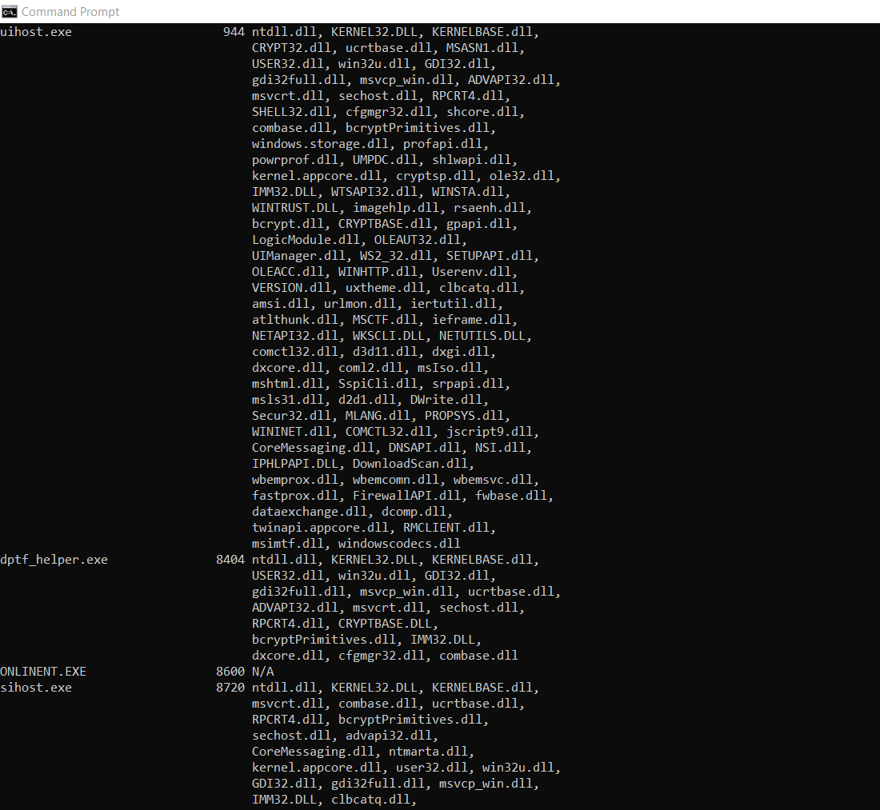

**Task kill –**

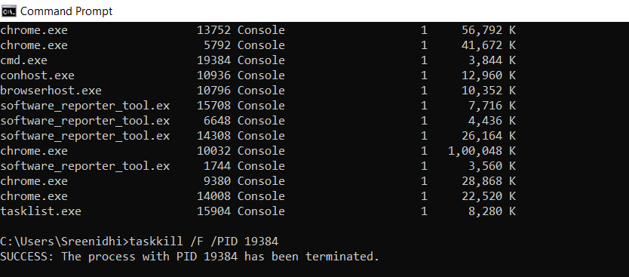

**Taskkill 2 –**

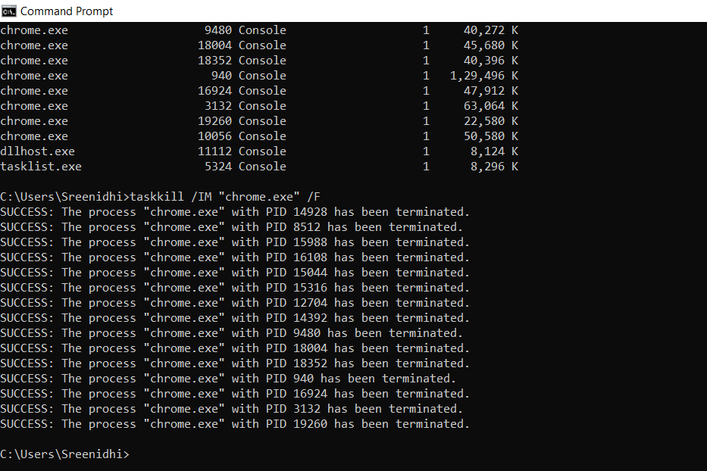

**Scheduling and Killing of a task –**

